**LAB PROJECT 04**

Oregon Tech

MIS 240: Linux Fundamentals

Ethan Dunzer

7/26/20

**Startup/Shutdown & Changing Runlevels**

**Editing GRUB**

* For these commands, you’ll need to be a super user (su) or root
  + find a command that allows you to stay as the root user
* Make the following changes to grub in /etc/default. Remember, to make changes, you’ll use a text editor like vi or nano.
  + Important: before making any changes to your grub file, make a backup copy of the original grub file, you’ll need to somehow identify your new file as the backup file (just in case things go wrong).
    - cp /etc/default/grub /etc/default/grub.bak
  + In the original grub file, change GRUB_TIMEOUT=0 to GRUB_TIMEOUT=30
  + Also, change the GRUB_TIMEOUT_SYTLE=menu
    - Save and close your text editor
    - Use the cat command to view your changes of the grub file
  + Run the following command to update your grub config
    - grub-mkconfig –o /boot/grub/grub.cfg

**\*\*\*Screenshot #1, show your grub-mkconfig command completed with no errors**

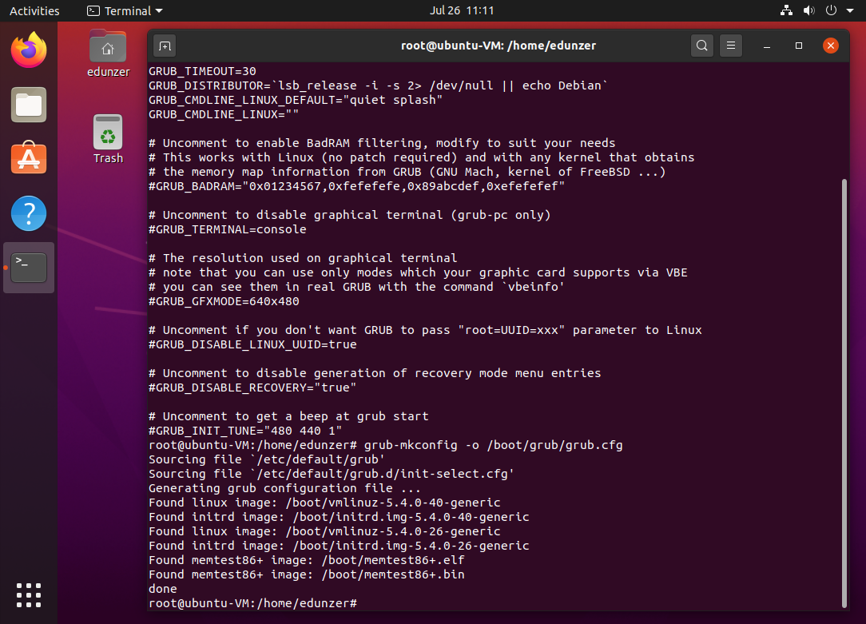

* Next, reboot your system using a proper reboot command. Be ready to take a screenshot of your grub menu showing more than 5 seconds.
* After you get your screenshot, go ahead and let the system boot normally.

**\*\*\*Screenshot #2, show your grub menu at boot with a countdown of 30 seconds**

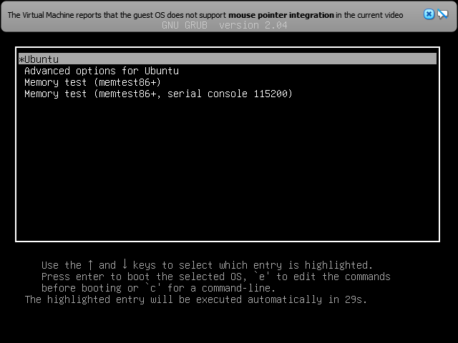

**Changing Runlevels**

Runlevels are determined when the system boots and each offers different levels of functionality when booted.  For example, in Windows, your computer always boots to the desktop.  Sometimes when you need to troubleshoot your computer, you boot Windows in Safe Mode.  This is the same as using a different runlevel in Linux.  Below is a chart showing the different runlevels available in your system.

|  |  |  |
| --- | --- | --- |
| **Runlevel** | **Description** | **Comments** |
| 0 | Halt | Halts the system (shutdown) |
| 1 | Single-user text mode | Root text mode, good for troubleshooting |
| 2 | Not used | Multi-user, system defined |
| 3 | Multiuser text mode | Network service, no GUI |
| 4 | Not used | Multi-user, system defined |
| 5 | Multi-user, GUI mode | Default; all services available |
| 6 | Reboot | Reboots the system |

* Log back into your system, open a shell, and switch to the root user
* Run the following command to see the different runlevels available on your system
  + ls /lib/systemd/system/runlevel*target –l
* Now, use the runlevel command to view your current runlevel. Your machine should be at runlevel 5.  The N in front of the 5 is the previous runlevel, N = none.  In other words, we went from no runlevel to 5 when we booted our VM.
* Run this command to view default targets loaded in systemd
  + - systemctl list-units –-type=target
    - This output shows you the default services that Linux loads when your system boots. Remember, our current runlevel is 5, meaning multi-user GUI mode with all services.  You should see services like networking, graphical interface, sound card, and file systems.
* Use the following command to view your default runlevel
  + systemctl get-default
    - Take note of your output

Graphical.target

* Use the following command to change you default runlevel to the rescue runlevel
  + sudo systemctl set-default rescue.target
* Use the command to view your new default runlevel
  + Note: this should have changed from graphical to rescue.
  + Take note of the symbolic link that was created. Explain

**\*\*\*Screenshot #3, show your change of default runlevel with an explanation of symbolic links**

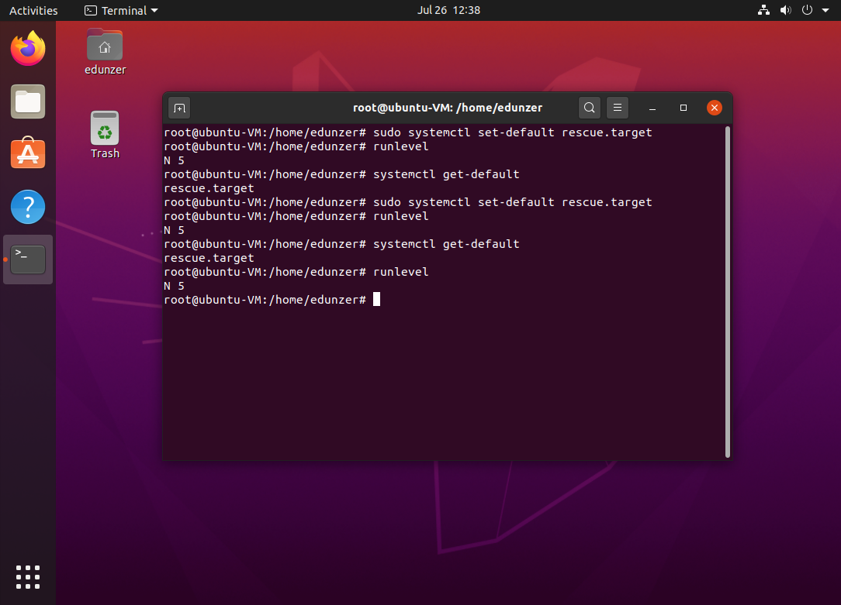

* Reboot your VM using the reboot
* Once your VM is rebooted, notice you are in rescue mode.

**\*\*\*Screenshot #4, show your VM in rescue mode**

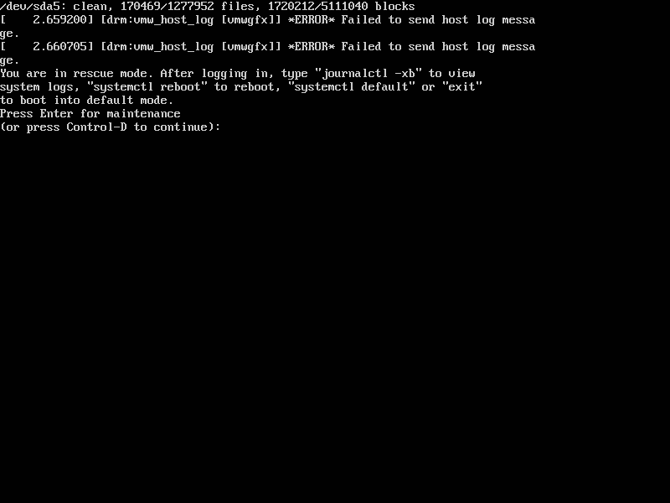

* Press the Enter key and notice you immediately drop down into a root shell
  + Notice, you don’t have a mouse! That’s because we’re no longer in a graphical environment.  Use the Right Ctrl key on your keyboard to capture and release your mouse when you’re going between Windows on your desktop.
  + Check your runlevel, what is your new runlevel?
* Use the same command learned above to change your default runlevel to multi-user.target.

**\*\*\*Screenshot #5, show your change of default runlevel**

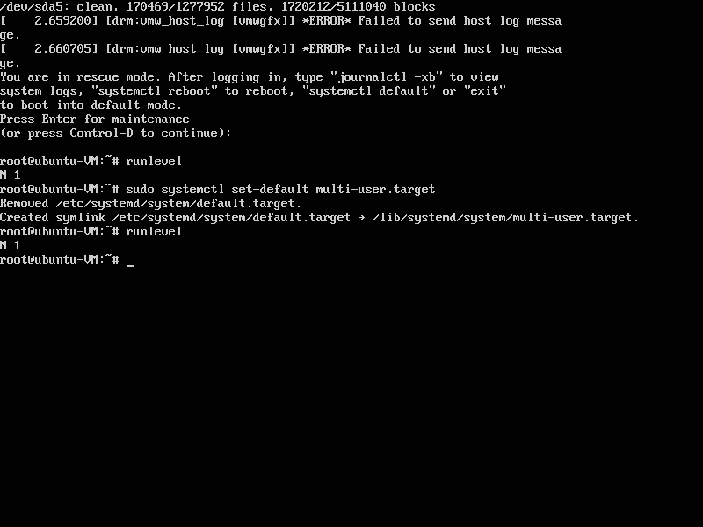runleve

* Reboot your VM using the reboot command
* Once your VM has finished booting, notice you still don’t have a graphical interface, but this time you can log in as any user
* Log in with your regular user account and your root password
  + Check your run level

**\*\*\*Screenshot #6, show you have booted using the multi-user.target default runlevel**

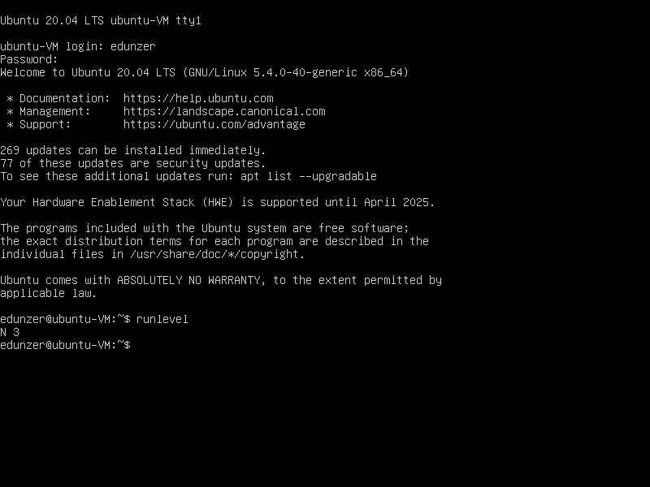

* Use the commands necessary to change your default runlevel back to graphical.target

**\*\*\*Screenshot #7, show your changed default runlevel**

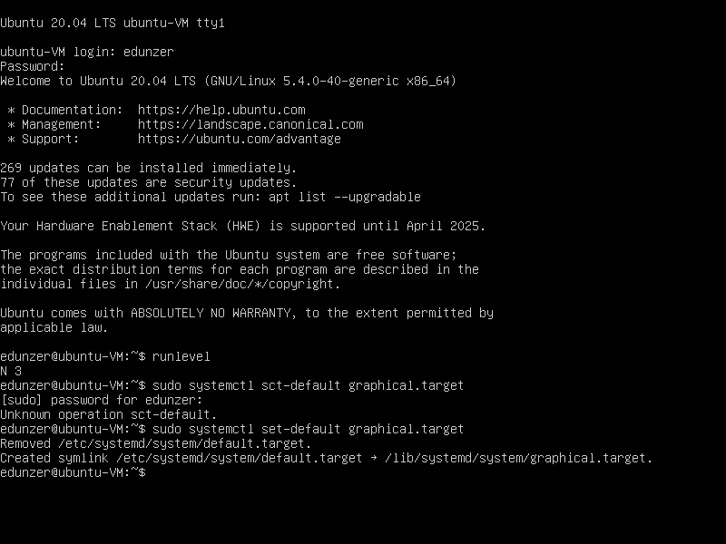

* Reboot your VM
* Once your VM is done booting, you should have your regular graphical login screen.

**\*\*\*Screenshot #8, show you have successfully made it back to your desktop**

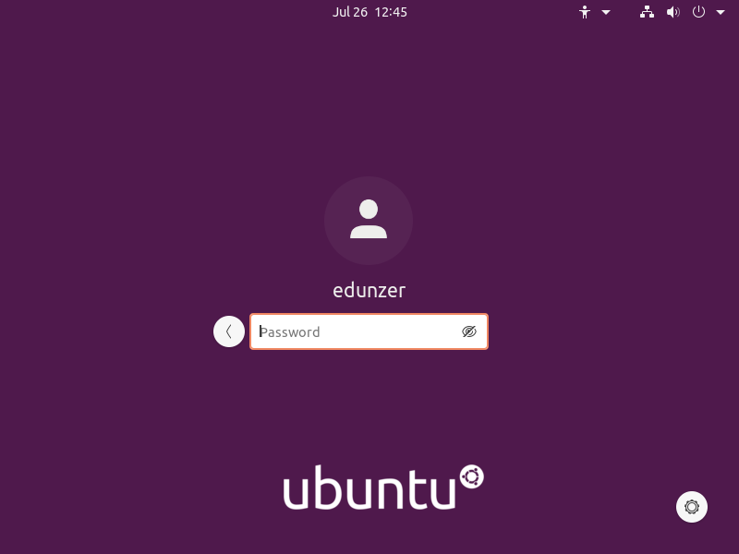

**Changing Runtime Runlevels**

The last steps showed you how to permanently change your default runlevel.  The next steps show you how to change runlevels during runtime, or in a live environment.

* Open a terminal, switch to the root account, and verify you are at runlevel 5.
* Use the following init command to change to runlevel 3 (multi-user, no GUI):
  + init 3
    - *Note: if you get a blank screen, press Ctrl+Alt+F1 to get a login prompt
  + Login with your account and run the startx command.

**\*\*\*Screenshot #10, show your ability to switch back and forth between init 3 and init 5**

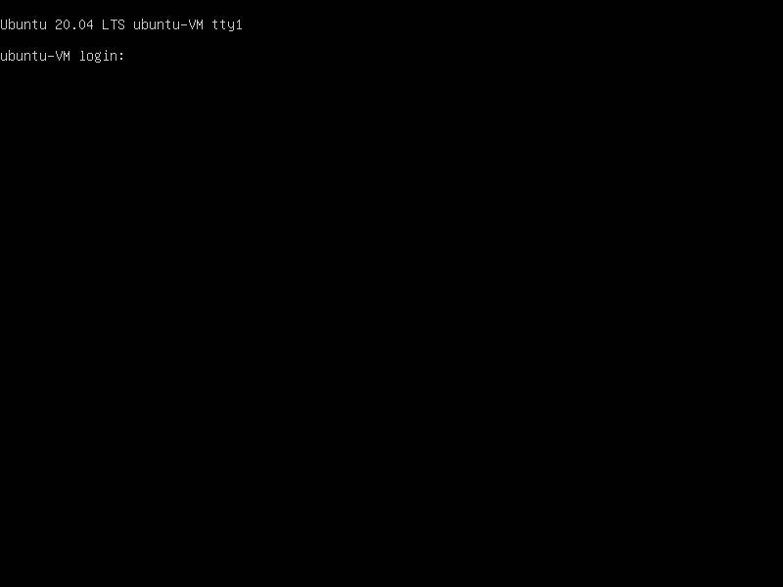



* Reboot and when you’re at the GRUB menu, press e to edit GRUB
* Arrow down and find the line that shows ‘linux /boot/…
  + Depending on your screen size, that line might flow over to a second line. Find where it says something like quite splash $vt_handoff
  + Add a space after handoff and enter 3, then press F10 to boot.
* Log in with your root account and verify your runlevel

**\*\*\*Screenshot #11, showing your runlevel from changed from the grub menu**

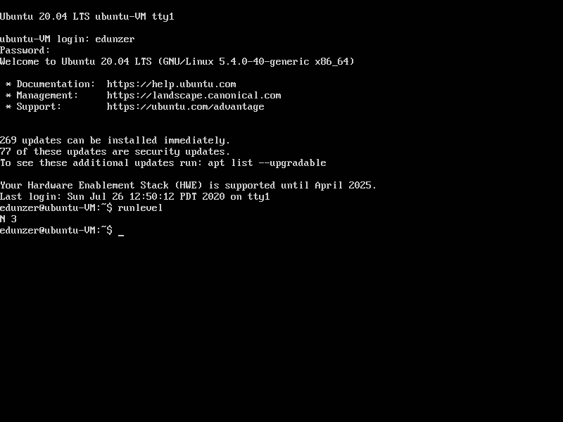

* Reboot your VM to return to your normal graphical desktop to finish the lab.

**Shutting down as a sysadmin**

* As root, you can setup shutdown commands with parameters and messages. This is useful when you need to reboot a system for maintenance, but you also want to alert users currently logged in, prompting them to save their work and close their programs.  Use the following command:
  + shutdown –h +15 “The system is going to restart in 15 minutes.” &
  + The ampersand “&” allows you to retain control over your shell
* For example, maybe you want to cancel your shutdown.
  + press enter and type shutdown –c
* You can also setup specific times, like:
  + shutdown –h 23:59 “This system will shutdown at 11:59 p.m.” &
* Again, shutdown –c to cancel

**\*\*\*Screenshot #12, show your successful shutdown commands**

